Shell Programming

1. Write a shell script that accepts a filename as an argument and displays whether it is a directory, a regular file, or something else.

Ans.

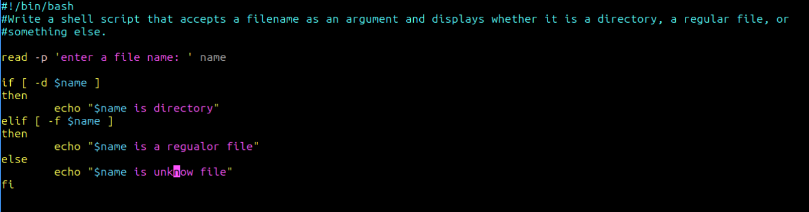

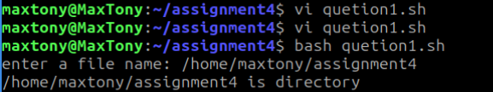

1. Write a script that reads a number and prints whether it is positive, negative, or zero.

Ans

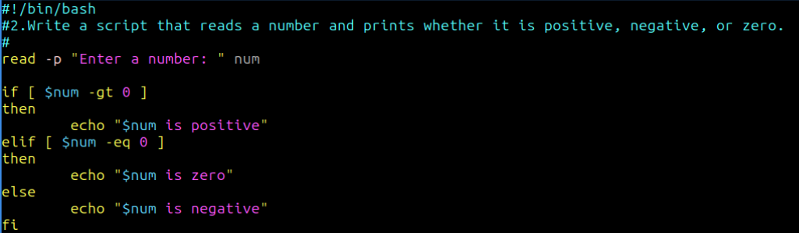

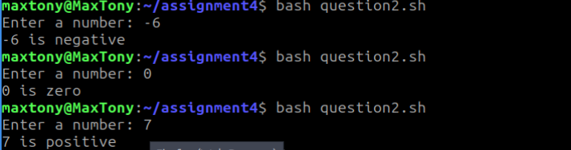

3.Write a script that accepts a username and checks whether the user is currently logged in.

Ans

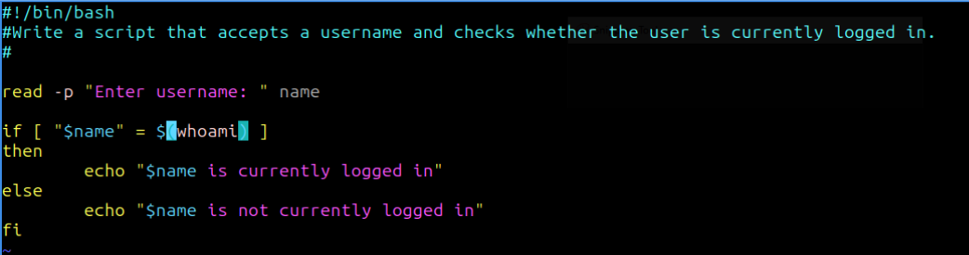

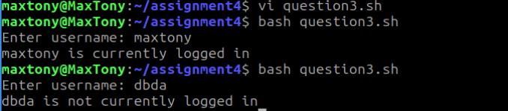

Write a script that prints the first 10 natural numbers using `until` loop.

Ans.

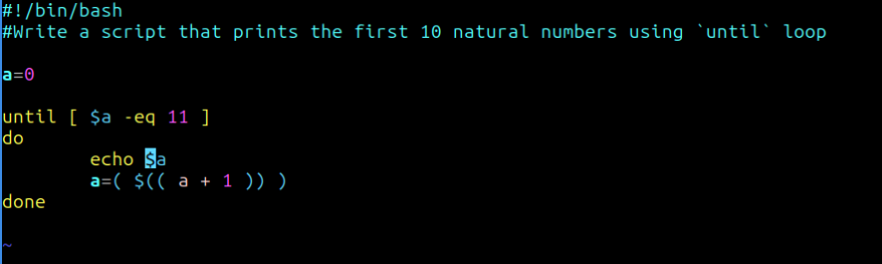

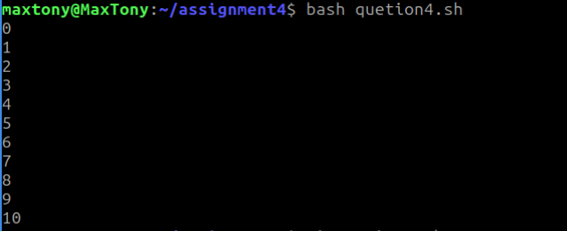

5. Write a script that demonstrates use of functions by creating one for addition and one for subtraction.

Ans.

